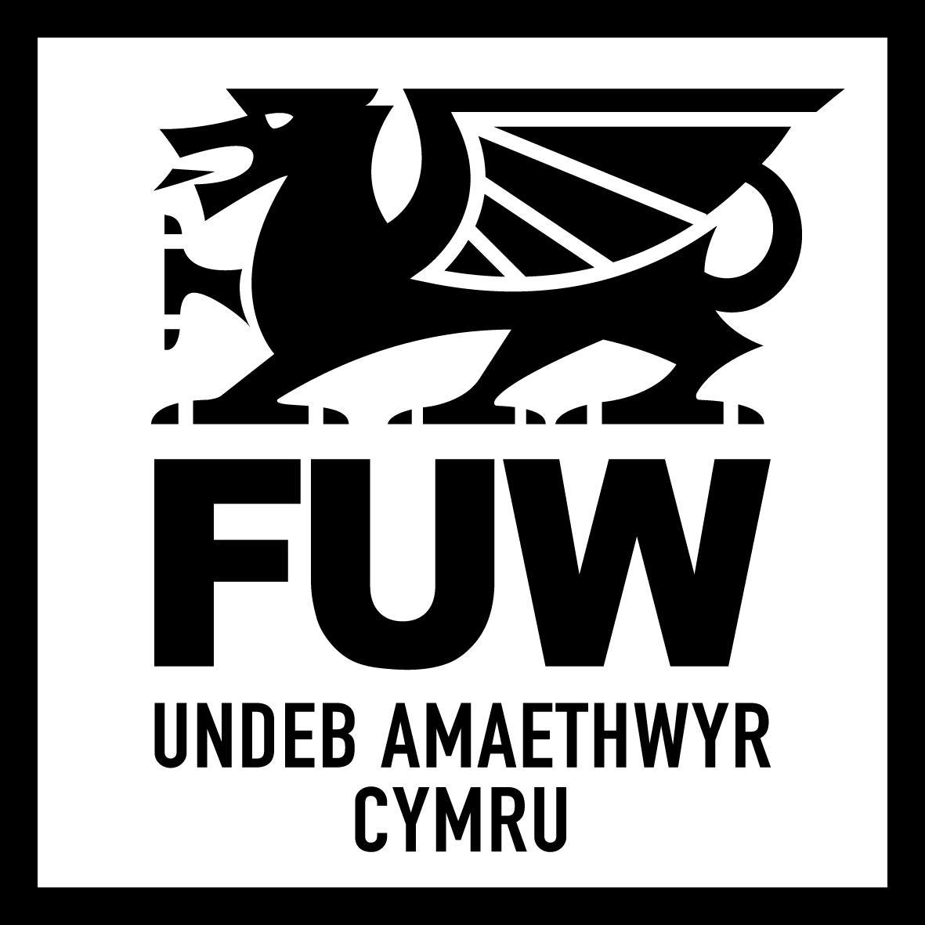

SAF DISCLAIMER FORM 2024 (PHONE APPOINTMENT)

I/WE……………………………………………………………………………………………………………………………………………………(NAMES)

OF………………………………………………………………………………………………………………………………………………………..…(ADDRESS)

HEREBY CONFIRM AND DECLARE THAT:

1. IT HAS BEEN EXPLAINED TO ME/US THAT THE FARMERS’ UNION OF WALES (FUW) ACCEPTS NO RESPONSIBILITY ON THE PART OF ITSELF OR ANY MEMBERS OF STAFF (THROUGH THEIR EMPLOYMENT), WHETHER IN CONTRACT, TORT (INCLUDING NEGLIGENCE) OR OTHERWISE IN CONNECTION WITH THE ASSISTANCE PROVIDED IN COMPLETING MY/OUR SAF FORM.
2. I/WE UNDERSTAND THAT IT IS MY/OUR RESPONSIBILITY TO PROVIDE FULL AND ACCURATE INFORMATION AS REQUESTED FOR THE COMPLETION OF THE SAID FORMS AND THAT THE FUW DO NOT ACCEPT ANY RESPONSIBILITY FOR INCORRECT INFORMATION GIVEN.
3. I/WE UNDERSTAND THAT IT IS MY/OUR RESPONSIBILITY TO ENSURE THAT I/WE COMPLY WITH ALL CROSS COMPLIANCE STANDARDS AS SET OUT IN 13 STATUTORY MANAGEMENT REQUIREMENTS (SMR) AND 7 GOOD AGRICULTURAL AND ENVIRONMENT CONDITIONS (GAEC) THESE INCLUDE RULES SUCH AS STOCK RECORD KEEPING, NVZ NUTRIENT MANAGEMENT WORKBOOK COMPLETION AND ANIMAL WELFARE STANDARDS.
4. I/WE UNDERSTAND THAT THE FUW IS ABLE TO ASSIST WITH THE COMPLETION AND SUBMISSION OF THE FORMS.
5. IT IS MY/OUR RESPONSIBILITY TO CHECK THE COMPLETED FORMS FOR ACCURACY AFTER THE FORM IS SUBMITTED ONLINE TO THE WELSH GOVERNMENT.
6. ONCE THE FORM HAS BEEN COMPLETED AND SUBMITTED I/WE CONFIRM THAT I/WE AM/ARE AWARE THAT THERE IS A 30 DAY PERIOD (RUNNING FROM THE DATE OF THE DEADLINE TO SUBMIT THE FORM) IN WHICH THE FORM CAN BE CHECKED FOR ANY OBVIOUS ERRORS. I/WE AGREE THAT I/WE WILL CHECK THE SUBMITTED FORM WITHIN THE RELEVANT PERIOD AND THAT I/WE WILL NOTIFY FUW IF THERE IS ANY INCORRECT INFORMATION ON THE SUBMITTED FORM OR IF ANY INFORMATION HAS BEEN OMITTED FROM THE SUBMITTED FORM.
7. IT IS MY/OUR DUTY TO MONITOR AND ENSURE THAT I/WE RECEIVE A SAF ACKNOWLEDGEMENT LETTER/EMAIL INCLUDING DETAILS OF FIELD AND SCHEMES CLAIMED DATA FROM THE WELSH GOVERNMENT (WITHIN 10 DAYS OF FORM SUBMISSION) AND THAT IT IS MY/OUR DUTY TO CHECK THE DATA ON THIS LETTER/EMAIL IN ORDER TO IDENTIFY ANY ERRORS OF WHICH I/WE WILL THEN IMMEDIATELY NOTIFY THE FUW.
8. IT IS MY/OUR DUTY TO CHECK THE DATA ON THE HARD/ELECTRONIC COPY OF THE SUBMITTED SAF IN ORDER TO IDENTIFY ANY ERRORS OF WHICH I/WE WILL THEN IMMEDIATELY NOTIFY THE FUW NO LATER THAN THE 15TH OF MAY OF THE RELEVANT YEAR OR ANY OTHER DATE THAT MIGHT BE ISSUED IN PLACE OF THIS DATE BY THE RELEVANT AUTHORITY.
9. I/WE ACKNOWLEDGE AND AGREE THAT THE DECISION TO PROVIDE ASSISTANCE BY TELEPHONE AND/OR EMAIL SHALL BE AT FUW’S SOLE DISCRETION.
10. I/WE CONSENT TO FUW COMPLETING AND SUBMITTING THE FORM ON MY/OUR BEHALF AND CONFIRM THAT ALL INFORMATION PROVIDED TO FUW WILL BE FULL AND CORRECT. I/WE ACKNOWLEDGE AND AGREE THAT FUW SHALL HAVE NO LIABILITY TO ME/US IN THE EVENT THAT I/WE PROVIDE INCORRECT OR MISLEADING INFORMATION OR IF I/WE OMIT ANY RELEVANT INFORMATION TO FUW.
11. I/WE AGREE TO FULLY INDEMNIFY FUW AGAINST ANY LOSSES THAT FUW MIGHT SUFFER OR INCUR AS A RESULT OF INCORRECT OR MISLEADING INFORMATION PROVIDED BY ME/US TO FUW OR IF I/WE OMIT RELEVANT INFORMATION FROM BEING PROVIDED TO FUW.
12. I/WE ACKNOWLEDGE THAT REGARDLESS OF THE METHOD OF ASSISTANCE PROVIDED BY FUW THE DISCLAIMERS IN THIS DOCUMENT APPLY AND THAT FUW SHALL HAVE NO LIABILITY FOR INCORRECT INFORMATION IN FORMS NOR THAT I/WE HAVE ANY RECOURSE AGAINST FUW FOR ANY INACCURATE INFORMATION, ERRORS OR OMISSIONS ON SUBMITTED FORMS.
13. BY READING THIS FORM I/WE AM/ARE NOW AWARE OF THE ABOVE DISCLAIMER AND CONFIRM THAT I/WE AM/ARE AWARE OF MY/OUR RIGHT TO OBTAIN INDEPENDENT LEGAL ADVICE AND THAT BY CONTINUING TO INSTRUCT THE FUW CONFIRM THAT I/WE ACCEPT THE ABOVE DISCLAIMER AND UNDERSTAND ITS CONSEQUENCES.

SIGNED ………………………………………………….. DATED………………………………..

ON BEHALF OF …………………………………………………(Trading Title of business)